# CD LAB 6:

NAME: Janvii RV

SRN: PES2UG22CS232

DATE: 23/04/2025

**CODE:**

hello.c

#include<stdio.h>

int main(){

    printf("Hello, World!\n");

    return 0;

}

**OUTPUT:**

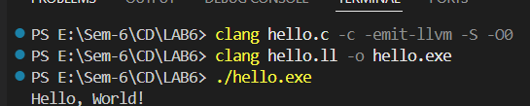

**CODE:**

demo2.c

#include<stdio.h>

int main(){

    for(int i=0; i<15; i++){

        printf("%d\n", i);

    }

}

**OUTPUT:**

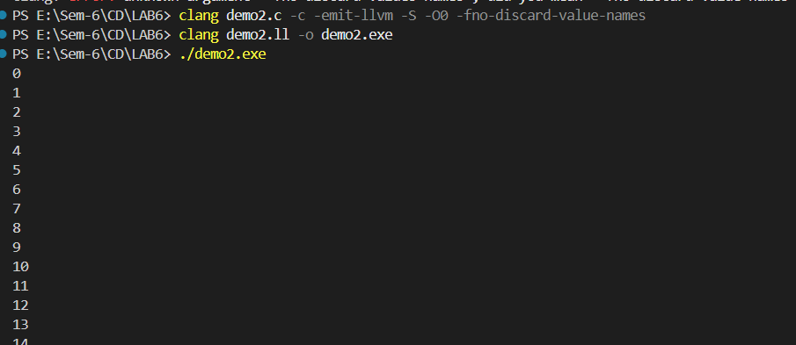

**CODE:**

**demo3.ll**

@s1 = constant [44 x i8] c"Hi!\0a- Name: Janvii RV\0a- Srn: PES2UG22CS232\0a\00"

declare i32 @printf(i8*, ...)

define i32 @main() {

%s1_ptr = getelementptr [44 x i8], [44 x i8]* @s1, i32 0, i32 0

call i32 (i8*, ...) @printf(i8* %s1_ptr)

ret i32 0

}

**OUTPUT:**

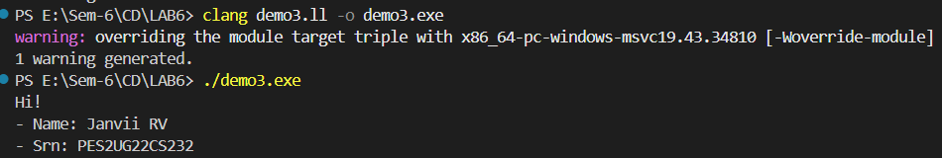

**CODE:**

script.py

llvm = r'''@s1 = constant [44 x i8] c"Hi!\0a- Name: Janvii RV\0a- Srn: PES2UG22CS232\0a\00"

declare i32 @printf(i8*, ...)

define i32 @main() {

  %s1_ptr = getelementptr [44 x i8], [44 x i8]* @s1, i32 0, i32 0

  call i32 (i8*, ...) @printf(i8* %s1_ptr)

  ret i32 0

}

'''

with open('output.ll', 'w') as file:

    file.write(llvm)

**OUTPUT:**

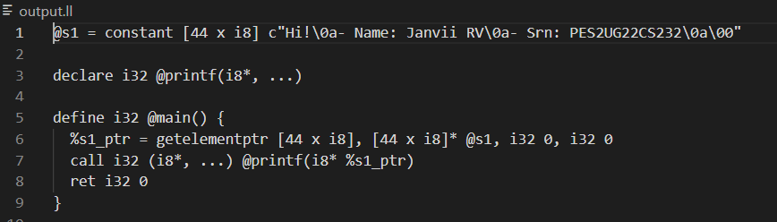

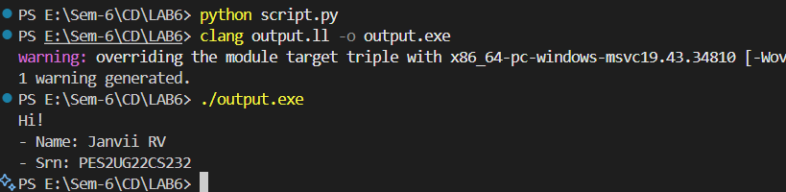

**CODE:**

**llvm.py**

llvm_global = r'''@s1 = constant [4 x i8] c"Hi\0A\00" '''

llvm_main = r''' 'define 132 @main) {'''

llvm_print = r'''

    $s1_ptr = getelementptr [4 x 18], [4 x 18]* @s1, i32 0, i32 0

    call 132(18*, ...) @printf(i8* %s1_ptr)'''

llvm_ret = r'''

ret 132 0

}'''

with open('output.ll', 'w') as file:

    file.write(llvm_global)

    file.write(llvm_main)

    file.write(llvm_print)

    file.write(llvm_print)

    file.write(llvm_print)

    file.write(llvm_ret)

**OUTPUT:**



